Recourses per taak.

 1:

Contact info:

Email: [tester@codecamp.com](mailto:tester@codecamp.com)Telefoon nummer: 06-123456789

Socials: @codecamptest voor ieder platform

2:

Link naar miro: https://miro.com/app/board/o9J_lrJ5dto=/

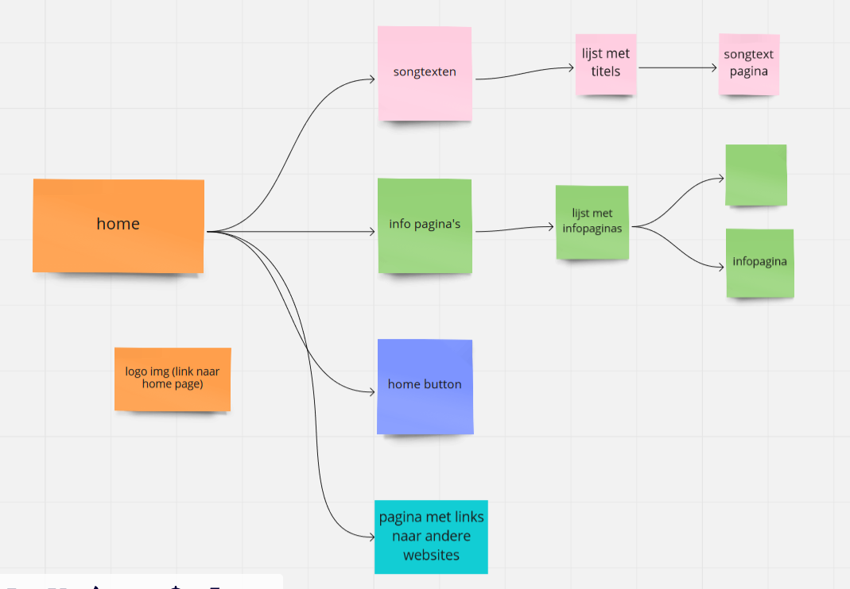

3a: --

3b: --

**4:Bohemian Rhapsody**

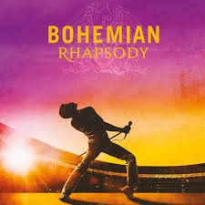[Queen](https://www.google.com/search?sxsrf=AOaemvJHRYgY5SyoNipOHMKXikWc1kTmIA:1633951943840&q=Queen&stick=H4sIAAAAAAAAAONgVuLQz9U3SMo2LFjEyhpYmpqaBwBspiu7FAAAAA&sa=X&ved=2ahUKEwie3MSpocLzAhWL16QKHey8CdAQMXoECBcQAw)

Is this the real life?   
Is this just fantasy?   
Caught in a landside,   
No escape from reality   
Open your eyes,   
Look up to the skies and see,   
I'm just a poor boy, I need no sympathy,   
Because I'm easy come, easy go,   
Little high, little low,   
Any way the wind blows doesn't really matter to   
Me, to me

Mamaaa,   
Just killed a man,   
Put a gun against his head, pulled my trigger,   
Now he's dead   
Mamaaa, life had just begun,   
But now I've gone and thrown it all away   
Mama, oooh,   
Didn't mean to make you cry,   
If I'm not back again this time tomorrow,   
Carry on, carry on as if nothing really matters

Too late, my time has come,   
Sends shivers down my spine, body's aching all   
The time   
Goodbye, everybody, I've got to go,   
Gotta leave you all behind and face the truth   
Mama, oooh   
I don't want to die,   
I sometimes wish I'd never been born at all.

I see a little silhouetto of a man,   
Scaramouch, Scaramouch, will you do the Fandango!

Thunderbolts and lightning, very, very frightening me   
Galileo, Galileo   
Galileo, Galileo   
Galileo, Figaro - magnificoo

I'm just a poor boy nobody loves me   
He's just a poor boy from a poor family,   
Spare him his life from this monstrosity   
Easy come, easy go, will you let me go   
Bismillah! No, we will not let you go   
(Let him go!) Bismillah! We will not let you go   
(Let him go!) Bismillah! We will not let you go   
(Let me go) Will not let you go   
(Let me go)(Never) Never let you go   
(Let me go) (Never) let you go (Let me go) Ah   
No, no, no, no, no, no, no   
Oh mama mia, mama mia, mama mia, let me go   
Beelzebub has a devil put aside for me, for me,   
For meee

So you think you can stop me and spit in my eye   
So you think you can love me and leave me to die   
Oh, baby, can't do this to me, baby,   
Just gotta get out, just gotta get right outta here

Nothing really matters, Anyone can see,   
Nothing really matters,   
Nothing really matters to me   
Any way the wind blows...

Kleurcode: #4682b4

5a: --

5b: --

6a: **Songtekst Killer Queen**

Kleurcode: #0000ff

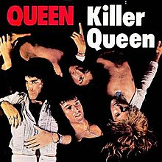Pagina – link: <https://genius.com/Queen-killer-queen-lyrics>

Info pagina: She keeps her Moet et Chandon   
In her pretty cabinet   
"Let them eat cake", she says   
Just like Marie Antoinette   
A built-in remedy   
For Khrushchev and Kennedy   
At anytime an invitation   
You can't decline

Caviar and cigarettes   
Well versed in etiquette   
Extraordinarily nice

She's a Killer Queen   
Gunpowder, gelatine   
Dynamite with a laser beam   
Guaranteed to blow your mind   
Anytime

Recommended at the price   
Insatiable an appetite   
Wanna try?

To avoid complications   
She never kept the same address   
In conversation   
She spoke just like a baroness   
Met a man from China   
Went down to Geisha Minah   
Then again incidentally   
If you're that way inclined

Perfume came naturally from Paris (naturally)   
For cars she couldn't care less   
Fastidious and precise

She's a Killer Queen   
Gunpowder, gelatine   
Dynamite with a laser beam   
Guaranteed to blow your mind   
Anytime

Drop of a hat she's as willing as   
Playful as a pussy cat   
Then momentarily out of action   
Temporarily out of gas   
To absolutely drive you wild, wild   
She's all out to get you

She's a Killer Queen   
Gunpowder, gelatine   
Dynamite with a laser beam   
Guaranteed to blow your mind   
Anytime

Recommended at the price   
Insatiable an appetite   
Wanna try?   
You wanna try

7: **Pagina madness van muse:**

**Kleur rood maroon #800000**

I, I can't get these memories out of my mind   
And some kind of madness has started to evolve   
I, I tried so hard to let you go   
But some kind of madness is swallowing me whole, yeah

I have finally seen the light   
And I have finally realized   
What you mean   
Oh oh oh

And now, I need to know is this real love   
Or is it just madness keeping us afloat?   
And when I look back at all the crazy fights we had   
Like some kind of madness   
Was taking control   
Yeah

And now I have finally seen the light   
And I have finally realized   
What you need   
Mm

And now I have finally seen the end (Finally seen the end)   
And I'm not expecting you to care (Expecting you to care)   
But I have finally seen the light (Finally seen the light)   
I have finally realized (Realized)   
I need to love   
I need to love

Come to me,   
Trust in your dream   
Come on and rescue me   
Yes I have known, I can be wrong   
Maybe I'm too headstrong   
Our love is   
Madness

8: **Pagina over boeken:**

Het **boek** is een veelgebruikte manier om [informatie](https://nl.wikipedia.org/wiki/Informatie) vast te leggen in de vorm van [tekst](https://nl.wikipedia.org/wiki/Tekst) en [afbeeldingen](https://nl.wikipedia.org/wiki/Illustratie) en om deze informatie weer te geven, op te slaan en te verspreiden. Het is een [document](https://nl.wikipedia.org/wiki/Document) van vaak niet al te kleine omvang.

Een boek in traditionele zin is een samengevoegde hoeveelheid papier met tekst, afbeeldingen of allebei. Daarnaast wordt met de term de betreffende informatie, of een soortgelijke verzameling informatie, aangeduid ('een boek schrijven', 'een boek downloaden').

Het [woord](https://nl.wikipedia.org/wiki/Woord) 'boek' is vermoedelijk afkomstig van het [Germaanse](https://nl.wikipedia.org/wiki/Germaanse_talen) woord voor [beuk](https://nl.wikipedia.org/wiki/Beuk_(boom)), *boche*. De omslagen van de eerste boeken werden namelijk gemaakt van een rechthoekig stuk (beuken)hout. Het [Griekse](https://nl.wikipedia.org/wiki/Grieks) woord *biblia* (boeken) is het meervoud van *biblion* dat oorspronkelijk '[papyrusje](https://nl.wikipedia.org/wiki/Papyrus_(schrift))' betekende, het materiaal waarop in de oudheid meestal werd geschreven, en later werd gebruikt als aanduiding van [papier](https://nl.wikipedia.org/wiki/Papier), [geschrift](https://nl.wikipedia.org/wiki/Handschrift_(boek)) en [boek(rol)](https://nl.wikipedia.org/wiki/Boekrol).

Voor de huidige boekvorm met [pagina's](https://nl.wikipedia.org/wiki/Bladzijde), de [codex](https://nl.wikipedia.org/wiki/Codex), werd uitgevonden, bestond geschreven informatieoverdracht al in de vorm van inbeiteling op steen, [boekrollen](https://nl.wikipedia.org/wiki/Boekrol) van [papyrus](https://nl.wikipedia.org/wiki/Papyrus_(schrift)) of [perkament](https://nl.wikipedia.org/wiki/Perkament), [kleitabletten](https://nl.wikipedia.org/wiki/Kleitablet), stukken bot, leren vellen en dergelijke. Korte notities die niet bewaard hoefden te blijven, werden meestal op potscherven geschreven. Dit kwam zo omdat in ieder huishouden schalen, bekers en voorraadvaten van [keramiek](https://nl.wikipedia.org/wiki/Keramiek) gebruikt werden en er geregeld wat brak zodat er aan scherven geen gebrek was.

9: **Songtekst Uprising**

Kleurcode: #ffa500

Pagina – link: https://muzikum.eu/nl/my-baby/uprising-songtekst

Info pagina: Allow me in your tub   
Just allow me in your club   
Allow me to drink from your cup   
I'll be coming back for more

Allow me in your dream   
Allow me in your scene   
Just allow me on your knees   
I'll be coming back for more

Sisters, keep on rising   
Brothers, keep on rising   
This girl keeps on rising   
Keep on rising up

All I Believe in your school   
I Believe in your rules   
I Believe in your truth   
I'll be coming back for more

I Believe in your land   
I Believe in that man   
I Believe in your command   
I'll be coming back for more

Sisters, Brothers, Lovers   
Keep on rising up

Sisters, keep on rising   
Brothers, keep on rising   
This girl keeps on rising   
Keep on rising up

Uprising, uprising   
Uprising, uprising

Sisters, Brothers, Lovers   
This girl keep on rising up

Sisters, keep on rising   
Brothers, keep on rising   
This girl keeps on rising   
Keep on rising up

**10:** Uprising

[Muse](https://www.google.com/search?sxsrf=AOaemvK9M2hA4ntZWDDS__bbqi87K8eIVg:1633947713242&q=Muse&stick=H4sIAAAAAAAAAONgVuLUz9U3MLQwr7BYxMriW1qcCgCqlr5OFAAAAA&sa=X&ved=2ahUKEwjPqJ3IkcLzAhUIKuwKHb2GC3YQMXoECA0QAw)

Paranoia is in bloom   
The PR transmissions will resume   
They'll try to push drugs that keep us all dumbed down   
And hope that we will never see the truth around   
(So come on)

Another promise, another scene   
Another packaged lie to keep us trapped in greed   
And all the green belts wrapped around our minds   
And endless red tape to keep the truth confined   
(So come on)

They will not force us   
They will stop degrading us   
They will not control us   
We will be victorious   
(So come on)

Interchanging mind control   
Come, let the revolution take its toll   
If you could flick the switch and open your third eye   
You'd see that we should never be afraid to die   
(So come on)

Rise up and take the power back   
It's time the fat cats had a heart attack   
You know that their time's coming to an end   
We have to unify and watch our flag ascend   
(So come on)

They will not force us   
They will stop degrading us   
They will not control us   
We will be victorious   
(So come on)

They will not force us   
They will stop degrading us   
They will not control us   
We will be victorious   
(So come on)

**11: james bond movie met rooger moore**

|  |  |  |  |  |  |  |  |
| --- | --- | --- | --- | --- | --- | --- | --- |
| **8** | [*Live and Let Die*](https://nl.wikipedia.org/wiki/Live_and_Let_Die_(film)) | 1973 | [Roger Moore](https://nl.wikipedia.org/wiki/Roger_Moore_(acteur)) | $ 7.000.000 | $ 126.000.000 | 6,8[[15]](https://nl.wikipedia.org/wiki/James_Bond_(mediafranchise)#cite_note-17) |  |
| **9** | [*The Man with the Golden Gun*](https://nl.wikipedia.org/wiki/The_Man_with_the_Golden_Gun) | 1974 | $ 13.000.000 | $ 97.600.000 | 6,8[[16]](https://nl.wikipedia.org/wiki/James_Bond_(mediafranchise)#cite_note-18) |  |
| **10** | [*The Spy Who Loved Me*](https://nl.wikipedia.org/wiki/The_Spy_Who_Loved_Me) | 1977 | Lewis Gilbert | $ 14.000.000 | $ 185.400.000 | 7,1[[17]](https://nl.wikipedia.org/wiki/James_Bond_(mediafranchise)#cite_note-19) |
| **11** | [*Moonraker*](https://nl.wikipedia.org/wiki/Moonraker) | 1979 | $ 34.000.000 | $ 210.300.000 | 6,3[[18]](https://nl.wikipedia.org/wiki/James_Bond_(mediafranchise)#cite_note-20) |
| **12** | [*For Your Eyes Only*](https://nl.wikipedia.org/wiki/For_Your_Eyes_Only) | 1981 | [John Glen](https://nl.wikipedia.org/wiki/John_Glen) | $ 28.000.000 | $ 194.900.000 | 6,8[[19]](https://nl.wikipedia.org/wiki/James_Bond_(mediafranchise)#cite_note-21) |
| **13** | [*Octopussy*](https://nl.wikipedia.org/wiki/Octopussy_(film)) | 1983 | $ 27.500.000 | $ 187.500.000 | 6,6[[20]](https://nl.wikipedia.org/wiki/James_Bond_(mediafranchise)#cite_note-22) |
| **14** | [*A View to a Kill*](https://nl.wikipedia.org/wiki/A_View_to_a_Kill) | 1985 | $ 30.000.000 | $ 152.400.000 | 6,3 |

**12:**

Plug in Baby

[Muse](https://www.google.com/search?biw=1536&bih=722&sxsrf=AOaemvIb8PFO1ksYLSm0nRrA64Y0uvH0yQ:1633948204941&q=Muse&stick=H4sIAAAAAAAAAONgVuLUz9U3MLQwr7BYxMriW1qcCgCqlr5OFAAAAA&sa=X&ved=2ahUKEwjQs9iyk8LzAhURNOwKHYuKAtoQMXoECAkQAw)

I've exposed your lies, baby   
The underneath no big surprise   
Now it's time for changing   
And cleansing everything   
To forget your love

My plug in baby   
Crucifies my enemies   
When I'm tired of giving   
My plug in baby   
In unbroken virgin realities   
Is tired of living

Don't confuse   
Baby you're gonna lose   
Your own game   
Change me   
And replace the envying   
To forget your love

My plug in baby   
Crucifies my enemies   
When I'm tired of giving   
My plug in baby   
In unbroken virgin realities   
And tired of living   
And I've seen your loving   
Mine is gone

**13:**

Een **cirkelzaag** (of radiaalzaag) is een [zaag](https://nl.wikipedia.org/wiki/Zaag) met een blad in de vorm van een stalen schijf, die met een motor tot een zeer hoog toerental wordt aangedreven. De schijf kan in een [zaagtafel](https://nl.wikipedia.org/w/index.php?title=Zaagtafel&action=edit&redlink=1) zijn gemonteerd waarover het te zagen materiaal wordt aangevoerd, of ingebouwd in een constructie samen met een [elektromotor](https://nl.wikipedia.org/wiki/Elektromotor) tot draagbare *handcirkelzaag*. Deze heeft een minder krachtige motor en kan ook dunner materiaal zagen.

Cirkelzaagbladen bestaan in soorten en maten, met allerlei verschillende vertandingen, en ook de diameter kan sterk verschillen (normaal is ca. 25 cm, maar industriële cirkelzagen met veel grotere bladen bestaan ook). De maximale zaagdiepte wordt bepaald door de straal van het cirkelzaagblad.

14a: --

14b: --

14c: --

**15:**

Kettingzaag

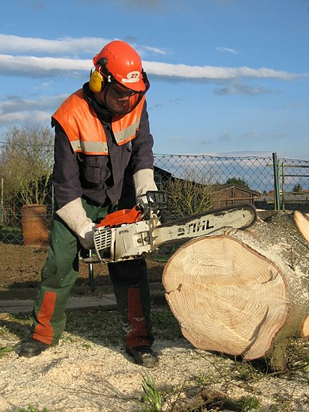

Een **kettingzaag** (ook **motorzaag**, **motorkettingzaag** of [**boomzaag**](https://nl.wikipedia.org/wiki/Boomzaag) genoemd) is een draagbare machine om mee te zagen. De belangrijkste functie is [hout](https://nl.wikipedia.org/wiki/Hout) zagen.

Verschillende typen[[bewerken](https://nl.wikipedia.org/w/index.php?title=Kettingzaag&veaction=edit&section=1) | [brontekst bewerken](https://nl.wikipedia.org/w/index.php?title=Kettingzaag&action=edit&section=1)]

Er zijn verschillende typen aandrijving voor kettingzagen: [pneumatisch](https://nl.wikipedia.org/wiki/Pneumatisch), [hydraulisch](https://nl.wikipedia.org/wiki/Hydraulisch), [elektrisch](https://nl.wikipedia.org/wiki/Elektrisch) en door middel van een [verbrandingsmotor](https://nl.wikipedia.org/wiki/Verbrandingsmotor) (vaak ook motorkettingzaag genoemd). De elektrische kettingzaag en de motorkettingzaag zijn het meest gangbaar.

**Elektrische kettingzaag**[[bewerken](https://nl.wikipedia.org/w/index.php?title=Kettingzaag&veaction=edit&section=2) | [brontekst bewerken](https://nl.wikipedia.org/w/index.php?title=Kettingzaag&action=edit&section=2)]

Elektrische kettingzagen zijn met name bedoeld voor particulier gebruik. Ze zijn milieuvriendelijker en maken doorgaans minder lawaai dan kettingzagen op benzine. Ze zijn praktischer in gebruik doordat ze lichter zijn. Elektrische kettingzagen zijn vaak goedkoper in aanschaf.

**Kettingzaag met brandstofmotor**[[bewerken](https://nl.wikipedia.org/w/index.php?title=Kettingzaag&veaction=edit&section=3) | [brontekst bewerken](https://nl.wikipedia.org/w/index.php?title=Kettingzaag&action=edit&section=3)]

Benzinekettingzagen hebben bijna zonder uitzondering een [tweetaktmotor](https://nl.wikipedia.org/wiki/Tweetaktmotor). Benzine-aangedreven kettingzagen hebben het voordeel dat ze een grotere mobiliteit hebben en krachtiger zijn dan elektrische kettingzagen.

16: Songtekst Transylvia

Kleurcode: #ff0000

Pagina – link: https://songteksten.net/lyric/3122/75377/mcfly/transylvania.html

Info pagina: Ann Boleyn she kept a tin   
Which all her hopes and dreams were in   
She plans to run away with him forever   
(Never to be seen again)

Leaves a note and starts to choke   
Can feel the lump that's in her throat   
It's raining and she leaves her coat in silence

We're sorry but we disagree   
The boy is vermin can't you see?   
We'll drown your sins in misery   
And rip him out of history

People marching to the drums   
Everybody's having fun   
To the sound of love   
Ugly is the world we're on   
If I'm right then prove me wrong   
I'm stunned to find a place I belong

Who-o is your lover?   
I couldn't tell   
When hell freezes over?   
That's when I'll tell   
O-oh means is your love her?   
I couldn't tell   
When will this stop?

Racing pacing in the dark   
She's searching for a lonely heart   
She finds him but his heart has stopped   
She breaks down

We're sorry but your majesty   
Refusing orders from the Queen   
Results in a monstrosity

Remembers a voice and hears him sing

People marching to the drums   
Everybody's having fun   
To the sound of love   
Ugly is the world we're on   
If I'm right then prove me wrong   
I'm stunned to find a place I belong

Who-o is your lover?   
I couldn't tell   
When hell freezes over?   
That's when I'll tell   
O-oh means you love her?   
I couldn't tell   
When will this stop?

People marching to the drums   
Everybody's having fun   
To the sound of love   
(Oooohhh)   
Ugly is the world we're on   
If I'm right then prove me wrong   
I'm stunned to find a place I belong   
Who-o is your lover?

I couldn't tell   
When hell freezes over?   
That's when I'll tell   
O-oh means you love her?

I couldn't tell   
When hell freezes over?   
That's when I'll tell   
Who-o is your lover?

I couldn't tell   
When hell freezes over?   
That's when I'll tell   
O-oh means you love her?

I couldn't tell   
When hell freezes over?   
That's when I'll tell   
Who-o is your lover?

I couldn't tell   
When hell freezes over?   
That's when I'll tell   
O-oh means you love her?   
I couldn't tell   
When hell freezes over?   
That's when I'll tell   
O-oh means you love her?   
I couldn't tell   
When hell freezes over?   
That's when I'll tell   
Who-o is your lover?   
I couldn't tell   
(Tell)   
(Tell)   
When will this stop?

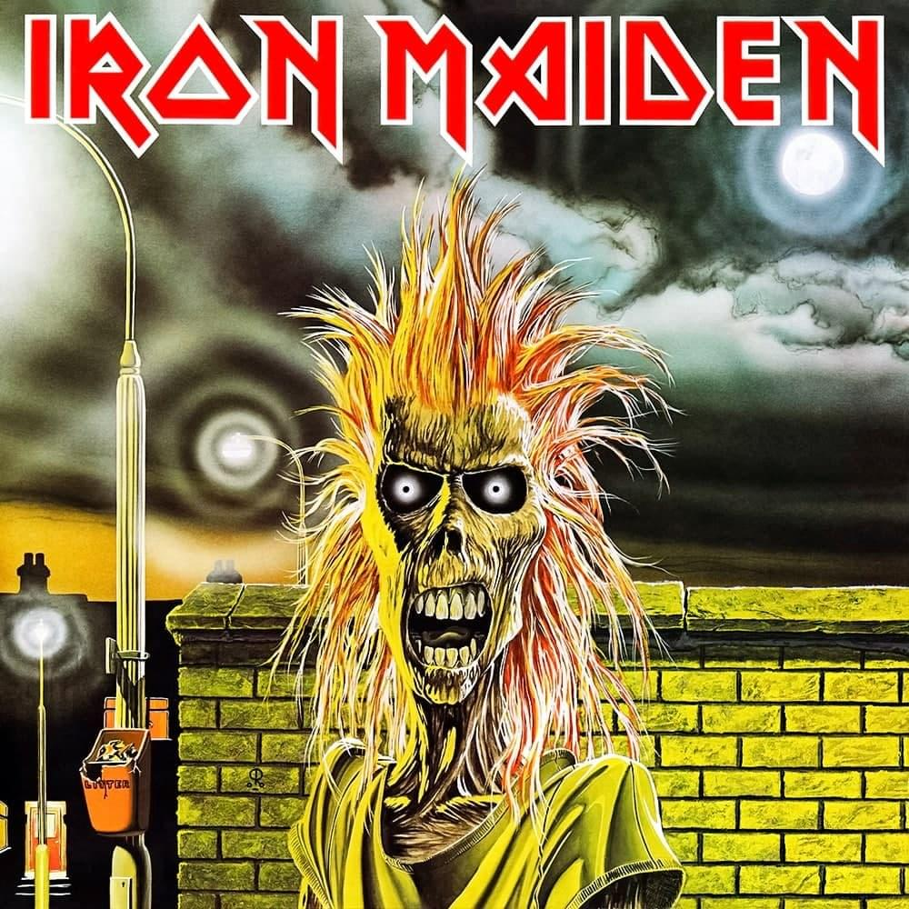

17:**Darth Vader**

Kleurcode: #ffff00 (Geel)

Pagina – link: https://disney.fandom.com/wiki/Darth_Vader

Info pagina: **Darth Vader** is a central character in the [*Star Wars*](https://disney.fandom.com/wiki/Star_Wars) universe, appearing as the central antagonist of the original trilogy.

He is the [Sith Lord](https://disney.fandom.com/wiki/Sith) persona of the fallen [Jedi Knight](https://disney.fandom.com/wiki/Jedi) [**Anakin Skywalker**](https://disney.fandom.com/wiki/Anakin_Skywalker) after his turn to the dark side. He remains the central antagonist until the events of *Return of the Jedi*, when he eventually redeems himself to save his son, [Luke Skywalker](https://disney.fandom.com/wiki/Luke_Skywalker) from his master [Darth Sidious](https://disney.fandom.com/wiki/Palpatine), fulfilling the Prophecy as the Chosen One.

After [Anakin Skywalker](https://disney.fandom.com/wiki/Anakin_Skywalker) finally embraced his inner darkness, the persona of Anakin ceased to exist, as the Darth Vader persona overtook him almost completely. Unlike most members of the [Sith Order](https://disney.fandom.com/wiki/Sith), Vader is not only capable of acknowledging his mistakes, but learning from them as well.

Vader became emotionally traumatized by the experience of the events on [Mustafar](https://disney.fandom.com/wiki/Mustafar). Vader is now terrifying, driven by rage, and his overconfidence has been further greatly amplified to the point of arrogance. However, after his defeat and mutilation on Mustafar at the hands of [Obi-Wan Kenobi](https://disney.fandom.com/wiki/Obi-Wan_Kenobi), he is no longer as arrogant and overconfident as he previously was. Although he eventually regained confidence in himself, it never came to the point of being outwardly arrogant or cocky.

Vader remains an impatient man, albeit to a far less extent, but generally presents himself as calm and level-headed. He rarely loses his temper and usually has good control over his emotions (something he was not able to do in his youth), but he has an extremely low tolerance for failure and any form of betrayal. Despite this, he is able to tolerate failure from his troops to a certain extent, although he becomes known for frequently killing his own men for even the slightest mistake. He also does not get along well at all with naval officers in the Imperial military. He has little to no tolerance for incompetence or for those who disrespect him for no clear reason, nearly choking Admiral Conan Antonio Motti to death when he disrespected Vader and challenged his powers of the Force. Vader telekinetically strangled Admiral Kendal Ozzel and Captain Lorth Needa for their incompetence. Many higher-ranking officers came to despise the Sith Lord and his "sorcerer's ways" for no clear reason.

Despite Vader's negative relationship with some higher-ranking officers in the military, he does get along reasonably well with the [Stormtroopers](https://disney.fandom.com/wiki/Stormtroopers) because of his front line leadership. One reason Vader became popular with the troops that served under him is his willingness to fight in the front line, and not expect of anyone anything he was not willing to do himself.

As Supreme Commander within the ranks of the Imperial Army of the [Galactic Empire](https://disney.fandom.com/wiki/Galactic_Empire), Vader is renowned for his leadership skills and admired by clones, middle/low-ranking officers, Sith, and politicians alike.

Despite what Vader's actions causes upon both himself and the galaxy, he apparently believes he is doing what is good for the galaxy, claiming not to feel regret. However, he actually secretly feels enormous shame and remorse for his actions, whether he wants to admit it or not. His feelings of guilt are so much that he develops a deep self-loathing and even nearly commits suicide at one point.

Vader is determined to never talk about his old life, wanting to distance himself from his painful past as best as possible. As a result, he detests anything that reminds him of his former-self, which he deems to be weak. It is for this reason that he showed no desire to restore the bond he once shared with his former apprentice and friend [Ahsoka Tano](https://disney.fandom.com/wiki/Ahsoka_Tano), as she is a living memory of everything he once was, and in his own twisted way, he became angry at her for leaving him and the [Jedi Order](https://disney.fandom.com/wiki/Jedi), something he perceived later on as a form of betrayal. Upon their fateful reunion, he did offer to spare her if she told him where the other lost Jedi were hiding, but cruelly resolved to kill her when she refused, and even when she found out he was indeed her former mentor and showed him compassion.

Due to Vader's former status as a slave, he has distress when the concept of slavery is brought up, despite the fact that the Empire made slavery legal again. He also can not return to his home planet [Tatooine](https://disney.fandom.com/wiki/Tatooine), as the planet is a painful reminder of him losing his mother, Shmi Skywalker. It was only after he found out about the existence of his son, [Luke Skywalker](https://disney.fandom.com/wiki/Luke_Skywalker), that Vader was able to muster the ability to return to Tatooine once more, and only because it was in search of information regarding his son.

Vader is cold, brutal, and ruthless towards his enemies, perfectly willing to terrorize, torture, and even murder them in cold-blood, although he does not take pleasure out of it. The exception to this might have been during his trip to Tatooine in search of information regarding his son, Luke Skywalker, during which he slaughtered an entire tribe of [Tusken Raiders](https://disney.fandom.com/wiki/Tusken_Raiders) (much as he had as Anakin) either out of vengeance or pleasure for what they did to his mother.

Vader is seemingly unfailingly loyal to his master, being [Sheev Palpatine](https://disney.fandom.com/wiki/Palpatine) the closest thing he has to a friend. However, in truth he secretly hates his master for deceiving him and ruining his life, even planning to overthrow him one day with his own apprentice. The only reason why Vader continued to serve Palpatine after losing his wife, was because the Emperor was all he had left of his former life as Anakin Skywalker and was the only one that would accept him. Ultimately, Vader is only truly loyal to the people he still cared about (like his son, Luke Skywalker), which is seen with him doing everything possible to protect his son from Palpatine.

Despite of these negative traits, Vader later proves that there was still good left in him. Upon discovering the existence of his son, Luke Skywalker, Vader became emotionally conflicted, unsure whether to continue serving his master or overthrow him with his son. He displayed a sense of compassion for Luke, revealing that some hint of him still had love for his family. This attachment ultimately led to his redemption.

Before the Battle of Endor had begun, Vader strongly believed that he was irredeemable and there was no good left in him. This belief was so strong that in a mental battle between his good and evil halves brought about after once being defeated by a powerful enemy. The evil Vader persona of his personality battled and destroyed the Anakin persona that represented his good side. However, when his son, Luke, was being tortured by Palpatine, he finally broke away from the dark side. At this point, Vader ceased to exist and Anakin returned in full force.

When Anakin sacrifices his life to save his son, before succumbing to the injuries he received from Palpatine, Anakin reconciled with Luke, and thanked his son for never giving up hope in saving him. He then died peacefully, becoming one with the Force.

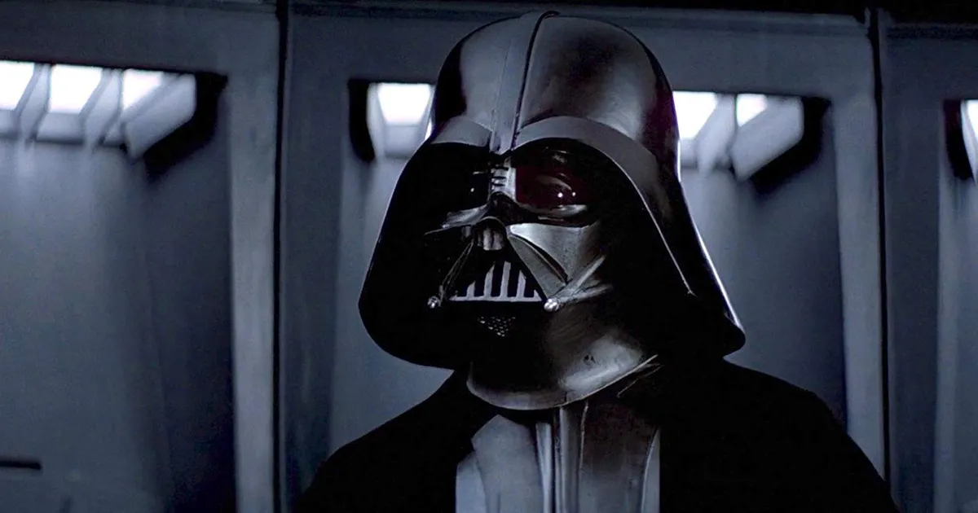

18:**Timoty Dalton**

Kleurcode: #008000 (Groen)

Pagina – link: https://jamesbond.fandom.com/wiki/Timothy_Dalton

Info pagina: Timothy Dalton was born in [Colwyn Bay](http://en.wikipedia.org/wiki/Colwyn_Bay), [Wales](http://en.wikipedia.org/wiki/Wales), [UK](http://en.wikipedia.org/wiki/UK), he is of mixed English and Italian-Irish ancestry. Soon after his birth, the family moved to [Belper](http://en.wikipedia.org/wiki/Belper), [Derbyshire](http://en.wikipedia.org/wiki/Derbyshire), [England](http://en.wikipedia.org/wiki/England), UK. He became interested in acting in his teenage years, and left school in 1962 to enrol in the [Royal Academy of Dramatic Art](http://en.wikipedia.org/wiki/Royal_Academy_of_Dramatic_Art) and tour with the [National Youth Theatre](http://en.wikipedia.org/wiki/National_Youth_Theatre) in the summer. He did not complete his RADA studies, leaving the academy in 1966 to join the ensemble of the [Birmingham Repertory Theatre](http://en.wikipedia.org/wiki/Birmingham_Repertory_Theatre). He quickly moved to television, working mainly with [BBC](http://en.wikipedia.org/wiki/BBC), and in 1968 made his film debut in [*The Lion in Winter*](http://en.wikipedia.org/wiki/The_Lion_in_Winter_(1968_film)), the first of several period dramas.

After a few more films, Dalton took a break in 1971 to concentrate on the theatre, performing with the [Royal Shakespeare Company](http://en.wikipedia.org/wiki/Royal_Shakespeare_Company) and other troupes throughout the world. With the exception of the 1975 film [*Permission to Kill*](http://en.wikipedia.org/wiki/Permission_to_Kill), he remained a theatre actor until 1978. That year he starred in [*Sextette*](http://en.wikipedia.org/wiki/Sextette), hailing his return to cinema and the beginning of his American career. While in the United States, Dalton worked mainly in television, although he starred in several European films and gave notable performances for the BBC.

In 1986, after [Roger Moore](https://jamesbond.fandom.com/wiki/Roger_Moore)'s retirement from the [James Bond](https://jamesbond.fandom.com/wiki/James_Bond) role, Dalton was approached to replace him but obligations to the film [*Brenda Starr*](http://en.wikipedia.org/wiki/Brenda_Starr) kept him from accepting the role. [Sam Neill](http://en.wikipedia.org/wiki/Sam_Neill) was then screentested for the part of Bond but was ultimately rejected by ["Cubby" Broccoli](https://jamesbond.fandom.com/wiki/Albert_R._Broccoli). [Pierce Brosnan](https://jamesbond.fandom.com/wiki/Pierce_Brosnan) was then approached for the role, but rescinded because of his commitment to the television revival of [*Remington Steele*](http://en.wikipedia.org/wiki/Remington_Steele). In the ensuing time, Dalton had completed the filming of *Brenda Starr* and was now able to accept the role of Bond.

Previously, Dalton had been offered the role in 1969 to replace [Sean Connery](https://jamesbond.fandom.com/wiki/Sean_Connery) after [*You Only Live Twice*](https://jamesbond.fandom.com/wiki/You_Only_Live_Twice), but turned it down feeling he was too young for the role and because of what he felt was an imposing legacy left behind by Connery. He was approached again following Connery's second departure after [*Diamonds Are Forever*](https://jamesbond.fandom.com/wiki/Diamonds_Are_Forever) but again declined, citing the same reasons. He was offered the part a third time in 1981 when [Roger Moore](https://jamesbond.fandom.com/wiki/Roger_Moore) decided to retire from the character prior to [*For Your Eyes Only*](https://jamesbond.fandom.com/wiki/For_Your_Eyes_Only); Dalton was apparently all but signed to the role when Moore decided to continue at the last moment. Work commitments made him again refuse the role in 1986, but when asked again, he finally agreed to appear in three James Bond films. The first, [*The Living Daylights*](https://jamesbond.fandom.com/wiki/The_Living_Daylights) (1987) was successful and grossed more than the previous two Roger Moore Bond films as well as contemporary box office rivals such as [*Die Hard*](http://en.wikipedia.org/wiki/Die_Hard) and [*Lethal Weapon*](http://en.wikipedia.org/wiki/Lethal_Weapon).

The second film, [*Licence to Kill*](https://jamesbond.fandom.com/wiki/Licence_to_Kill) (1989) did not perform as well at the U.S. box office, partly due to a lacklustre marketing campaign, after the title of the film was abruptly changed from *Licence Revoked*, and partly because it was released in competition with other action blockbusters *Batman*, *Indiana Jones and the Last Crusade*, *Lethal Weapon 2*, *Ghost Busters II*, *Honey I Shrunk the Kids* and *Back to the Future Part II* over the summer of 1989. As a direct result of the latter, no Bond movie since has been released over the summer months. However, MGM reported a net profit of $28.2 million for the film.

Dalton's [third Bond film](https://jamesbond.fandom.com/wiki/Unmade_Bond_17_(1991)) (rumoured title: *The Property of A Lady*) was due for a 1991 release but its production was scuttled by internecine corporate litigation between Danjaq, LLC, the copyright holder of James Bond on screen and [MGM](https://jamesbond.fandom.com/wiki/MGM)/[United Artists](https://jamesbond.fandom.com/wiki/United_Artists) (Giancarlo Parretti), the financier and distributor of the series. In 1994, tired of waiting for a film that seemed as though it would never happen, Dalton officially dropped the James Bond role, re-opening the door for Pierce Brosnan.

Dalton's portrayal of Bond - darker, more grittily realistic and truer to the original character as portrayed in Fleming's novels - was something of a double-edged sword. Critics welcomed a more serious interpretation after more than a decade of Roger Moore's lighthearted approach but the reaction of Moore aficionados and those who had grown up with Moore as their Bond during his 15 year tenure and were generally unfamiliar with [Ian Fleming](https://jamesbond.fandom.com/wiki/Ian_Fleming)'s original novels was mixed. Despite the contemporary criticism, rumours persist to this day that Dalton had always been high on "Cubby" Broccoli's list of ideal Bond actors. More recent evaluation has warmed somewhat to Dalton's brief tenure, with some critics noting the similarities between his gritty performance and that of [Daniel Craig](https://jamesbond.fandom.com/wiki/Daniel_Craig).



19:

**Info pagina  luke skywalker:**



**Kleur:** Groen bijvoorbeeld #A3EBB1

Luke Skywalker, a [Force-sensitive](https://starwars.fandom.com/wiki/Force-sensitive) [human](https://starwars.fandom.com/wiki/Human) [male](https://starwars.fandom.com/wiki/Gender), was a legendary [Jedi Master](https://starwars.fandom.com/wiki/Jedi_Master) who fought in the [Galactic Civil War](https://starwars.fandom.com/wiki/Galactic_Civil_War) during the [reign](https://starwars.fandom.com/wiki/Imperial_Era) of the [Galactic Empire](https://starwars.fandom.com/wiki/Galactic_Empire). Along with his companions, [Princess](https://starwars.fandom.com/wiki/Prince) [Leia Organa](https://starwars.fandom.com/wiki/Leia_Skywalker_Organa_Solo) and [General](https://starwars.fandom.com/wiki/General) [Han Solo](https://starwars.fandom.com/wiki/Han_Solo), Skywalker served as a revolutionary on the side of the [Alliance to Restore the Republic](https://starwars.fandom.com/wiki/Alliance_to_Restore_the_Republic)—an organization committed to the downfall of the [Galactic](https://starwars.fandom.com/wiki/The_galaxy) [Empire](https://starwars.fandom.com/wiki/Politics#Empire) and the restoration of [democracy](https://starwars.fandom.com/wiki/Democracy). Following the war, Skywalker became a living legend, and was remembered as one of the greatest [Jedi](https://starwars.fandom.com/wiki/Jedi) in [galactic history](https://starwars.fandom.com/wiki/Timeline_of_galactic_history).

The son of [Jedi Knight](https://starwars.fandom.com/wiki/Jedi_Knight) [Anakin Skywalker](https://starwars.fandom.com/wiki/Anakin_Skywalker) and [Senator](https://starwars.fandom.com/wiki/Senator) [Padmé Amidala](https://starwars.fandom.com/wiki/Padm%C3%A9_Amidala), Luke Skywalker was [born](https://starwars.fandom.com/wiki/Reproduction) along with his [twin](https://starwars.fandom.com/wiki/Twin) sister, Leia, in [19 BBY](https://starwars.fandom.com/wiki/19_BBY). As a result of Amidala's [death](https://starwars.fandom.com/wiki/Death) and Anakin's fall to the [dark side of the Force](https://starwars.fandom.com/wiki/Dark_side_of_the_Force), the Skywalker [children](https://starwars.fandom.com/wiki/Youngling) were separated and sent into hiding, with Leia adopted by the [royal family](https://starwars.fandom.com/wiki/House_of_Organa) of [Alderaan](https://starwars.fandom.com/wiki/Alderaan) while Luke was raised by his [relatives](https://starwars.fandom.com/wiki/Lars_family) on [Tatooine](https://starwars.fandom.com/wiki/Tatooine). Longing for a life of adventure and purpose, Skywalker joined the Rebellion and began learning the ways of [the Force](https://starwars.fandom.com/wiki/The_Force) under the guidance of Jedi Master [Obi-Wan Kenobi](https://starwars.fandom.com/wiki/Obi-Wan_Kenobi), whose first [apprentice](https://starwars.fandom.com/wiki/Padawan) was Luke's own [father](https://starwars.fandom.com/wiki/Parent). During the [Battle of Yavin](https://starwars.fandom.com/wiki/Battle_of_Yavin) in [0 BBY](https://starwars.fandom.com/wiki/0_BBY), Skywalker saved the Alliance from annihilation by destroying the Empire's [planet](https://starwars.fandom.com/wiki/Planet)-killing [superweapon](https://starwars.fandom.com/wiki/Superweapon), the [Death Star](https://starwars.fandom.com/wiki/DS-1_Death_Star_Mobile_Battle_Station). He continued his [training](https://starwars.fandom.com/wiki/Jedi_training) in the [years](https://starwars.fandom.com/wiki/Standard_year) that followed, determined to become a Jedi Knight like his father before him, and found a new mentor in [Grand Master](https://starwars.fandom.com/wiki/Grand_Master) [Yoda](https://starwars.fandom.com/wiki/Yoda). After his master's death, Skywalker participated in the [Battle of Endor](https://starwars.fandom.com/wiki/Battle_of_Endor) in [4 ABY](https://starwars.fandom.com/wiki/4_ABY), during which he confronted the [Sith Lord](https://starwars.fandom.com/wiki/Sith_Lord) [Darth](https://starwars.fandom.com/wiki/Darth) Vader, whom he [learned](https://starwars.fandom.com/wiki/Duel_on_Cloud_City) was in fact his father, Anakin Skywalker. With Luke's help, Anakin returned to the [light side of the Force](https://starwars.fandom.com/wiki/Light_side_of_the_Force) by killing [Galactic Emperor](https://starwars.fandom.com/wiki/Galactic_Emperor) [Darth Sidious](https://starwars.fandom.com/wiki/Darth_Sidious) at the cost of his own life, fulfilling his destiny as the [Chosen One](https://starwars.fandom.com/wiki/Chosen_One). Following the Battle of Endor, Skywalker trained his sister as a first Jedi apprentice on [Ajan Kloss](https://starwars.fandom.com/wiki/Ajan_Kloss), but Leia ended her training after the birth of her son and seeing his death as a result of finishing her knighthood.

With the [Sith](https://starwars.fandom.com/wiki/Sith)'s destruction and the subsequent [capitulation](https://starwars.fandom.com/wiki/Galactic_Concordance) of the Empire in [5 ABY](https://starwars.fandom.com/wiki/5_ABY), Luke Skywalker traveled across the [galaxy](https://starwars.fandom.com/wiki/Galaxy), searching for knowledge that would aid him in rebuilding the [Jedi Order](https://starwars.fandom.com/wiki/Jedi_Order). One of his apprentices was his sister's son, [Ben Solo](https://starwars.fandom.com/wiki/Ben_Solo), who inherited the [Skywalker bloodline's](https://starwars.fandom.com/wiki/Skywalker_family) raw strength and potential for limitless power. As master and padawan, Skywalker traveled with his nephew and battle the knights of Ren, studied lost Jedi lore, and gathered others to expand their new order's ranks. In [28 ABY](https://starwars.fandom.com/wiki/28_ABY), Skywalker, glimpsing the darkness in his padawan, briefly contemplated murdering him, causing Solo to fall to the dark side like Vader before him and destroy his nascent order. The loss of his nephew haunted Skywalker for the rest of his life. In addition, the [destruction](https://starwars.fandom.com/wiki/Destruction_of_the_Jedi_Temple) of his temple and murder of all his students convinced him that the [time](https://starwars.fandom.com/wiki/Time) had come for the Jedi to end. He therefore sought [exile](https://starwars.fandom.com/wiki/Exile_(punishment)) on the [distant](https://starwars.fandom.com/wiki/Unknown_Regions) world of [Ahch-To](https://starwars.fandom.com/wiki/Ahch-To), having elected to live out his remaining [days](https://starwars.fandom.com/wiki/Standard_day) as a [hermit](https://starwars.fandom.com/wiki/Hermit) despite the galaxy's pleas for help during the [rise](https://starwars.fandom.com/wiki/Cold_War) of the [First Order](https://starwars.fandom.com/wiki/First_Order).

His solitude was interrupted in [34 ABY](https://starwars.fandom.com/wiki/34_ABY), shortly after the [fall](https://starwars.fandom.com/wiki/Hosnian_Cataclysm) of the [New Republic](https://starwars.fandom.com/wiki/New_Republic), resulting in a chain of events that led Skywalker to play [one last, momentous role](https://starwars.fandom.com/wiki/Battle_of_Crait) in the conflict between light and darkness. Although he [passed away into the Force](https://starwars.fandom.com/wiki/Force_spirit), his legend would spread throughout the galaxy, rekindling a spark of hope in the enemies of the First Order. Before his death, Skywalker declared that the Jedi Order would not die with him, having trained a final apprentice: the [Jakku](https://starwars.fandom.com/wiki/Jakku) [scavenger](https://starwars.fandom.com/wiki/Scavenger) known as [Rey](https://starwars.fandom.com/wiki/Rey_Skywalker).

In [35 ABY](https://starwars.fandom.com/wiki/35_ABY), Skywalker's spirit communed with Rey during the final days of the [war](https://starwars.fandom.com/wiki/First_Order/Resistance_War). The Jedi apprentice had exiled herself to Ahch-To, following in Skywalker's example. However, Skywalker urged Rey to [confront](https://starwars.fandom.com/wiki/Battle_of_Exegol) her [grandfather](https://starwars.fandom.com/wiki/Palpatine_family), the [resurrected](https://starwars.fandom.com/wiki/Cloning) Darth Sidious. Believing he had been wrong, Skywalker told Rey that a Jedi's destiny was to confront fear. Following the Emperor's destruction, the spirits of Skywalker and his sister watched over Rey as she buried their lightsabers in Skywalker's [childhood home](https://starwars.fandom.com/wiki/Lars_Homestead) on Tatooine and adopted the Skywalker name as her own to honor their legacy.

**Links:** <https://starwars.fandom.com/wiki/Luke_Skywalker>

20:

**Pagina over hamsters:**

**Hamsters** (Cricetinae) zijn een onderfamilie van de knaagdierfamilie [Cricetidae](https://nl.wikipedia.org/wiki/Cricetidae) die voorkomt in [Azië](https://nl.wikipedia.org/wiki/Azi%C3%AB) en [Europa](https://nl.wikipedia.org/wiki/Europa_(continent)). Een aantal soorten hamsters kunnen als [huisdier](https://nl.wikipedia.org/wiki/Huisdier) worden gehouden. Hamsters zijn het nauwste verwant aan de Noord-Amerikaanse [Neotominae](https://nl.wikipedia.org/wiki/Neotominae). De bekendste soorten zijn de [gewone hamster](https://nl.wikipedia.org/wiki/Hamster) (*Cricetus cricetus*), die ook in Nederland en België voorkomt, en de [goudhamster](https://nl.wikipedia.org/wiki/Goudhamster), ook Syrische hamster genoemd (*Mesocricetus auratus*), die veel als huisdier wordt gehouden.

**Hamsters als huisdier**

Er zijn vijf soorten hamsters die als huisdier worden gehouden. Ten eerste is er de wat grotere [goudhamster](https://nl.wikipedia.org/wiki/Goudhamster) (*Mesocricetus auratus*). De naam goudhamster stamt uit de tijd dat ze slechts in de oorspronkelijke gouden wildkleur voorkwamen. Tegenwoordig bestaan er meerdere kleurvarianten, waardoor de term Syrische hamster gepaster is. Verder zijn er vier dwerghamstersoorten: de [Russische of Siberische dwerghamster](https://nl.wikipedia.org/wiki/Russische_dwerghamster) (*Phodopus sungorus sungorus*), [Campbells dwerghamster](https://nl.wikipedia.org/wiki/Campbells_dwerghamster) (*Phodopus sungorus campbelli*), de [Roborovskidwerghamster](https://nl.wikipedia.org/wiki/Woestijndwerghamster) (*Phodopus roborovskii*) en de [Chinese dwerghamster](https://nl.wikipedia.org/wiki/Chinese_dwerghamster) (*Cricetulus griseus*). Laatstgenoemde behoort als enige tot de familie van de ratachtige hamsters. In [dierenwinkels](https://nl.wikipedia.org/wiki/Dierenwinkel) treft men voornamelijk Syrische hamsters en Russische dwerghamsters aan, maar Campbells dwerghamster en Roborovskidwerghamsters winnen aan populariteit.[[bron?]](https://nl.wikipedia.org/wiki/Wikipedia:Bronvermelding#Bron_gevraagd) Dwerghamsters variëren ook nog eens in verschillende maten, de Roborovskidwerghamsters is hiervan het kleinste. Ze leven vooral op [steppen](https://nl.wikipedia.org/wiki/Steppe), maar ook op [landbouwgrond](https://nl.wikipedia.org/wiki/Landbouw), met name op [leemgronden](https://nl.wikipedia.org/wiki/Leem). Een hamster wordt gemiddeld anderhalf tot drie jaar oud. In uitzonderlijke gevallen kunnen hamsters leeftijden van vier jaar of ouder bereiken.

**Gedrag in gevangenschap**

De meeste hamsters zijn solitaire dieren. Syrische hamsters en Chinese dwerghamsters zijn solitair, dus ook in gevangenschap moeten ze alleen in een kooi gehouden worden. Meerdere dieren in één kooi leidt tot conflicten met als gevolg de dood van een van beide hamsters. Roborovskidwerghamsters, Russische dwerghamsters en de Campbelli dwerghamster[[bron?]](https://nl.wikipedia.org/wiki/Wikipedia:Bronvermelding#Bron_gevraagd) zijn wel groepsdieren en kunnen ook in gevangenschap met meerdere bij elkaar gehouden worden. Toch zijn niet alle hamsters gesteld op gezelschap en kan het voorkomen dat ook bij deze soorten de hamsters afzonderlijk gehouden moeten worden.[[bron?]](https://nl.wikipedia.org/wiki/Wikipedia:Bronvermelding#Bron_gevraagd)

Hamsters geven wel geur af. Vrouwelijke Syrische hamsters kunnen een wat sterkere geur afscheiden als ze in hun vruchtbare periode zitten, eens in de vier dagen.

Hamsters zijn schemerdieren en brengen de dag grotendeels slapend door in een holletje of nestje dat ze in hun kooi van krantensnippers, wc-papier, hooi of bedding zullen bouwen. Er zijn ook watten van puur katoen te koop, maar deze producten zorgen voor verstrikking en verstikken.

**voedsel**

Hamsters eten vooral zaden en andere plantaardige voedingsstoffen, maar ook dierlijke eiwitten. In de natuur worden hamsters vaak door [vossen](https://nl.wikipedia.org/wiki/Vos_(dier)), [marters](https://nl.wikipedia.org/wiki/Marters) en [uilen](https://nl.wikipedia.org/wiki/Uilen_(orde)) opgegeten.

**ziekten**

Hamsters hebben over het algemeen weinig problemen met hun gezondheid, toch kan een simpele verkoudheid een hamster al fataal worden. Een gezonde hamster, kijkt levendig uit zijn ogen en heeft een zachte, egale vacht. Bij een zieke hamster is de vacht erg dof en open, waarbij het lijkt of de vacht vochtig is. Het dier zit dan meestal in elkaar gedoken en heeft, ook tijdens het lopen, een hoge rug. Dierenartsen weten vaak niet hoe ze een hamster moeten behandelen, omdat het kleine dieren zijn. De grootste gevaren zijn er voor de [Syrische hamster](https://nl.wikipedia.org/wiki/Syrische_hamster), dit zijn tocht en vocht. Wanneer een hamster ziek is, heeft het vooral een rustige schemerige omgeving nodig. Stress, drukte en lawaai kunnen de genezing van een hamster tegenwerken. Een hamster moet het niet te warm en niet te koud hebben. Een omgeving met een temperatuur van tussen de 20 en 21 graden is goed. Niet alleen de hamster, maar ook andere knaagdieren overlijden vaak binnen een paar dagen wanneer er geen dierenarts bezocht wordt om het dier te genezen.

21:

**Pagina plug in baby :**

[Verse 1]   
I've exposed your lies, baby   
[The underneath's no big surprise](https://genius.com/Muse-plug-in-baby-lyrics#note-5230331)[Now it's time for changing   
And cleansing everything   
To forget your love](https://genius.com/Muse-plug-in-baby-lyrics#note-2679247)[Chorus]   
[My plug in baby](https://genius.com/Muse-plug-in-baby-lyrics#note-2766112)[Crucifies my enemies   
When I'm tired of giving, whoa](https://genius.com/Muse-plug-in-baby-lyrics#note-2679253)My plug in baby   
[In unbroken virgin realities   
Is tired of living](https://genius.com/Muse-plug-in-baby-lyrics#note-2679257)[Verse 2]   
[Don't confuse   
Baby you're gonna lose   
Your own game](https://genius.com/Muse-plug-in-baby-lyrics#note-5074178)[Change me   
And replace the envying   
To forget your love](https://genius.com/Muse-plug-in-baby-lyrics#note-5231786)[Chorus]   
[My plug in baby](https://genius.com/Muse-plug-in-baby-lyrics#note-2766112)[Crucifies my enemies   
When I'm tired of giving, whoa](https://genius.com/Muse-plug-in-baby-lyrics#note-2679253)My plug in baby   
[In unbroken virgin realities   
Is tired of living](https://genius.com/Muse-plug-in-baby-lyrics#note-2679257)[[Outro]](https://genius.com/Muse-plug-in-baby-lyrics#note-4574298)[And I've seen your loving   
Mine is gone   
And I've been in trouble](https://genius.com/Muse-plug-in-baby-lyrics#note-5233047)[Wooaahhh](https://genius.com/Muse-plug-in-baby-lyrics#note-4231483)

Kleur rood : #800000

Maroon

**6b:**

We Are the Champions

[Queen](https://www.google.com/search?sxsrf=AOaemvINyQoAeRF1L_qd8SO_IOQ32MqGVw:1633952058490&q=Queen&stick=H4sIAAAAAAAAAONgVuLQz9U3SMo2LFjEyhpYmpqaBwBspiu7FAAAAA&sa=X&ved=2ahUKEwj3nJrgocLzAhUND-wKHVShA3MQMXoECBEQAw)

I've paid my dues   
Time after time   
I've done my sentence   
But committed no crime   
And bad mistakes   
I've made a few   
I've had my share of sand   
Kicked in my face   
But I've come through

And we mean to go on and on and on and on

We are the champions, my friends   
And we'll keep on fighting till the end   
We are the champions   
We are the champions   
No time for losers   
'Cause we are the champions of the World

I've taken my bows   
And my curtain calls   
You brought me fame and fortune   
And everything that goes with it   
I thank you all   
But it's been no bed of roses   
No pleasure cruise   
I consider it a challenge before   
The human race   
And I ain't gonna lose

And we mean to go on and on and on and on

We are the champions, my friends   
And we'll keep on fighting till the end   
We are the champions   
We are the champions   
No time for losers   
'Cause we are the champions of the World

We are the champions, my friends   
And we'll keep on fighting till the end   
We are the champions   
We are the champions   
No time for losers   
'Cause we are the champions of the World

22: links naar pagina's

**https://www.imdb.com/**

**https://www.videoland.com/nl/**

movies.nl

23: --

24a: --

24b: --

24c: --

25a: --

25b: --